**Boolean Expressions:**

- A statement that can either be trueor false **-** Has to be objective (1 is a number) not subjective (1 is the best number)  
- **bool** – Is a special type in Python called a **boolean variable**, it is either True or False

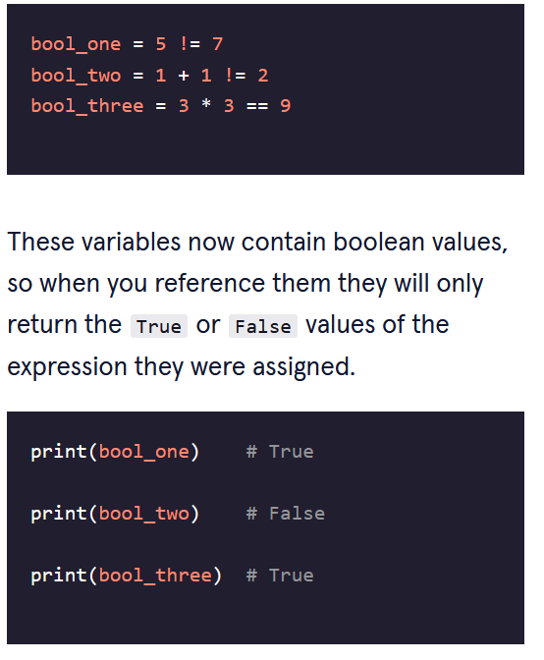

**Relational Operators (Comparators):**

- Compare two items and return either True or False  
- **Equals: ==  
- Not Equals: !=**

**Determining Type:**

- Can determine the data type of an argument passed to the function using **type()**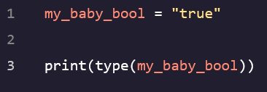

**Conditional Statement:**

- If this happens then do this  
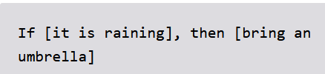 (Pseudocode)  
- In Python, instead of using “then” we use a colon to tell computer what will happen next  
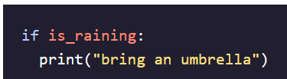

**Relational Operators II:**

- **> -** Greater than **- >= -** Greater than or equal to **- < -** Less than **- <= -** Less than or equal to

**Boolean Operators:**

**- and –** Combines two Boolean expressions and evaluates as True if **BOTH** of its components are true, else it displays False  
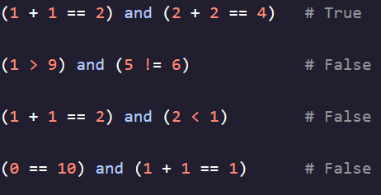 **- or –** Combines two expressions into a larger expression that is True if **EITHER** or **BOTH** expressions are true  
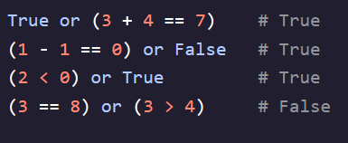 **- not –** Reverses the value of a statement. It makes True expressions False, and False expressions True  
- Applied at the beginning of a statement  
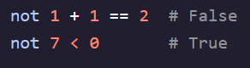

**Else Statements:**

- Allow us to describe what we want to happen in our code when certain conditions are **not** met  
- Appear in conjunction with *if* statements   
- Prevents us from having to write *if* statements for each possible condition, we can instead write a blanket *else* statement for all the times the condition is **not** met  
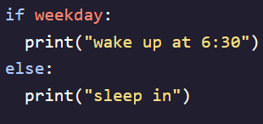

**Elif Statements:**

- Checks the lines of code after the *if* statement to see if they match the criteria.   
- First the *if* statement is checked, then each *elif* statement is checked top to bottom then finally the *else* code is executed if none of the previous conditions have been met  
- In the code below if we used all *if* commands then it would print every line if someone donated $1100 because that value satisfies all the greater than criteria’s  
- By using *elif* statements, for a $600 donation, we tell the code to check the first line, False, then the second line, True, then it doesn’t check anymore of the statements because they are *elif* and *else* statements   
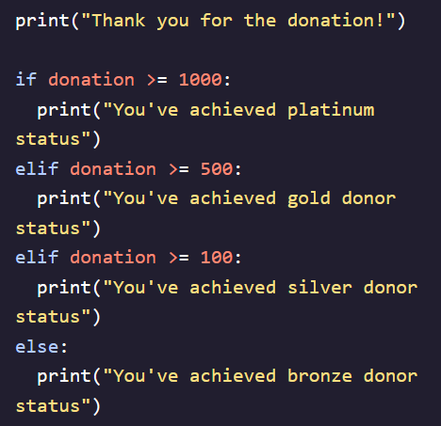 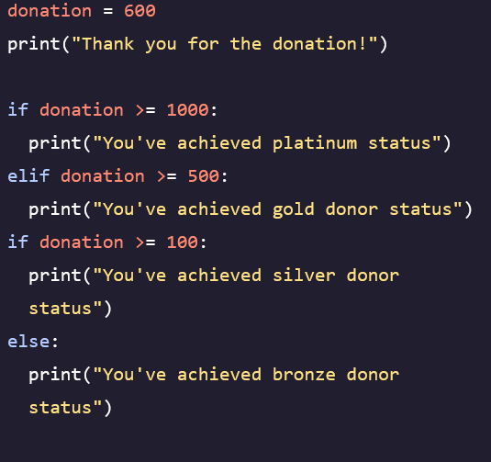 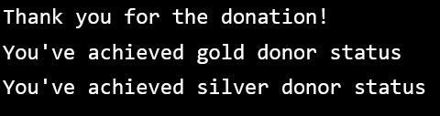

Output from above code when last *elif* statement is changed to an *if* statement

**Random Number Generator:**

* Can use the *import random* and *randint()* functions to generate a random number for a variable
* Variables in the parenthesis are *inclusive* meaning they include the values 1 AND 9

